The MimicB60 board is an addressable synoptic system which can drive up to 60-LEDs.
The MimicB60 product is made of an electronic board mounted into a plastic socket compatible with OMEGA rail fixing.
The MimicB60 board is compatible with Héphaïs 1600 and Héphaïs 1600 NE. A maximum of 3 boards can be connected on a loop and each is declared by 60 addresses on the loop.

Main characteristics

- 60 addressable leds fully programmable
- Embedded isolator
- Rail DIN installation
- Led panels associated
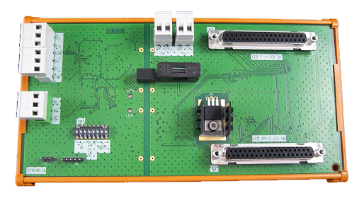
Electrical characteristics
Communication bus voltage |  | Extreme: 12 to 28V  Nominal: 24Vdc
Leds power supply |  | Extreme: 15 to 28V  Nominal: 24Vdc
Standby consumption (under 24V) |  | 24mA
Initialisation duration (switch on) |  | <1.0 sec
Energy reserve (in case of power failure) |  | < 4 sec
Leds output, power |  | 17 W (60Leds) i.e 24V/12mA max per led
Leds output, type |  | Leds output in common anode
Short-circuit isolator
Max. current | - ISmax = 1.0 A in commutation  - ICmax = 400mA in permanence (closed isolator)  - ILmax = 100µA (open isolator)
Impedance (line switch) | < 400mΩ @ 400mA when closed  - 100KΩ when opened
Switch opening voltage | 9 Vdc < Uline < 10Vdc
Fuse
Nominal current | 1.0A
Dimensions in mm (l x w) | 20 x 5
Mechanical characteristics
Weight | 320 g (with female connectors)
Dimension in mm (l x w x h) | 206x109x60.5
Protection index | IP00 (no protection)
Climatic characteristics
Operating mode Temperature | From -10°C to +60°C
Operating mode Humidity | ≤ 93% HR
Storage Temperature | From -10°C to +60°C
Storage Humidity | ≤ 93% HR

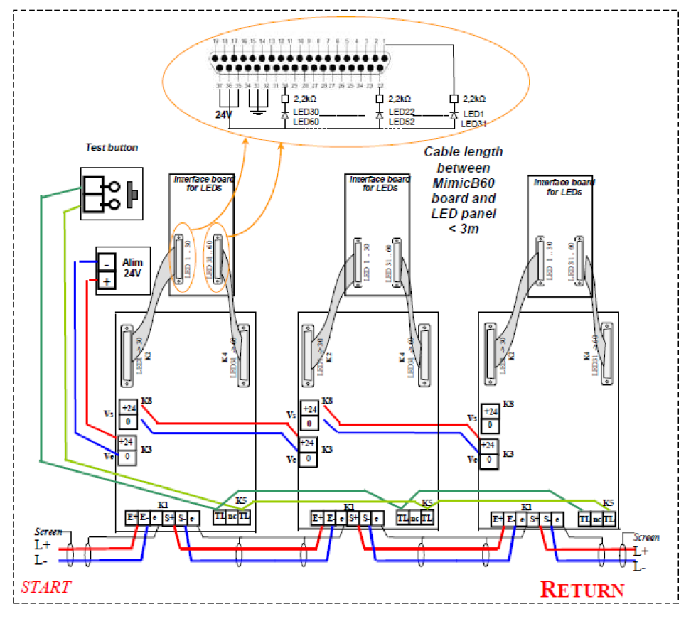

REFERENCE DESCRIPTION
MIMICB60 DIN RAIL MOUNTING 60 ADDRESSABLE outputs dedicated for Mimic panel leds

